HKCEM

College Monthly Meeting

OSCE - August 2015

Q1. A 29-year-old lady sustained a fall at home with right eye injury.

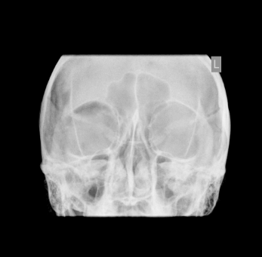

* 1. Describe ONE important x ray finding? (1 mark)
  2. What is the name of the sign? (1 mark)
  3. What is the diagnosis? (1 mark)

1.4 Name 3 the other radiographic signs that may be found in this condition? (not necessarily in this patient) (3 marks)

1.5 Name 3 management principles for this patient? (3 marks)

1.6 What is your advice to the patient before discharge? (1 mark)

Q2. A 20-year-old man complained of left chest pain after being hit by others during basketball game.

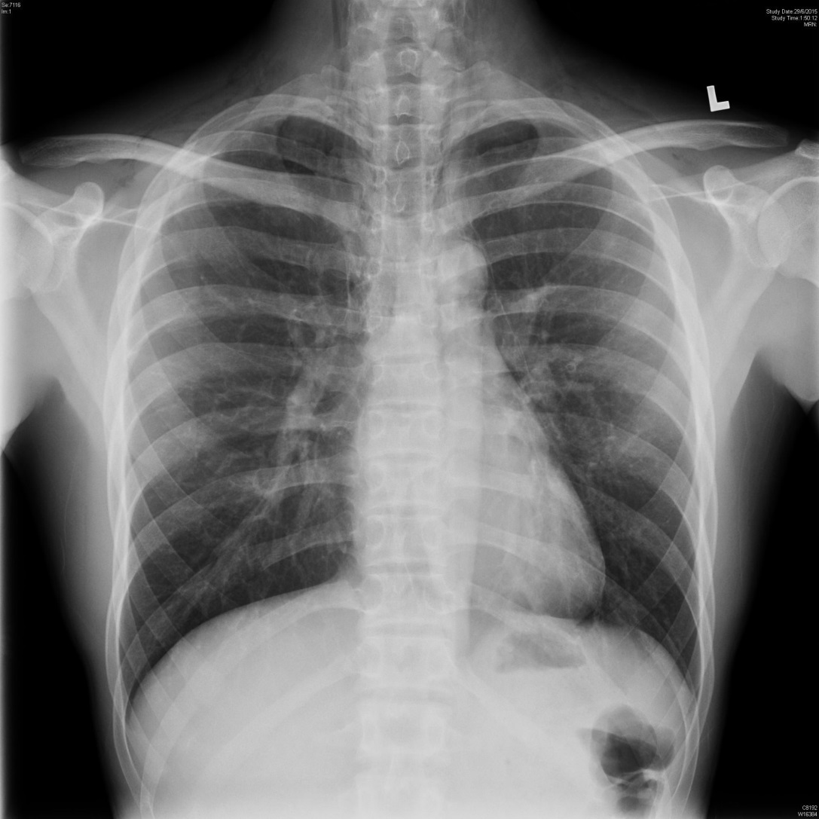

2.1 What are the TWO x ray findings? (2 marks)

2.2 Name 4 possible causes of the above condition. (4 marks)

2.3 What are the TWO clinical signs that may be present in physical examination? (2 marks)

2.4 Name 2 other radiographic signs that may be found in this condition. (2 marks)

Q3. A 62-year-old gentleman with history of ischemic cardiomyopathy and ICD

implantation. He complained of palpitations and shocks delivered by ICD.

3.1 What are the functional capabilities of an ICD? (2 marks)



3.2 What is the ECG rhythm? (1 mark)

3.3 Name 3 management principles for this patient? (3 marks)

3.4 After you have finished your physical examination, he complained of palpitations and dizziness. BP rechecked 80/ 42.

What is the ECG rhythm? (1 mark)



3.5 What should be the treatment now? (1 mark)

3.6 Any precautions with your treatment? (2 marks)

Q4. This 54-year-old woman attended AED after right index finger injury by snake

bite a few hour ago. From the patient's description, it was a Bamboo snake.

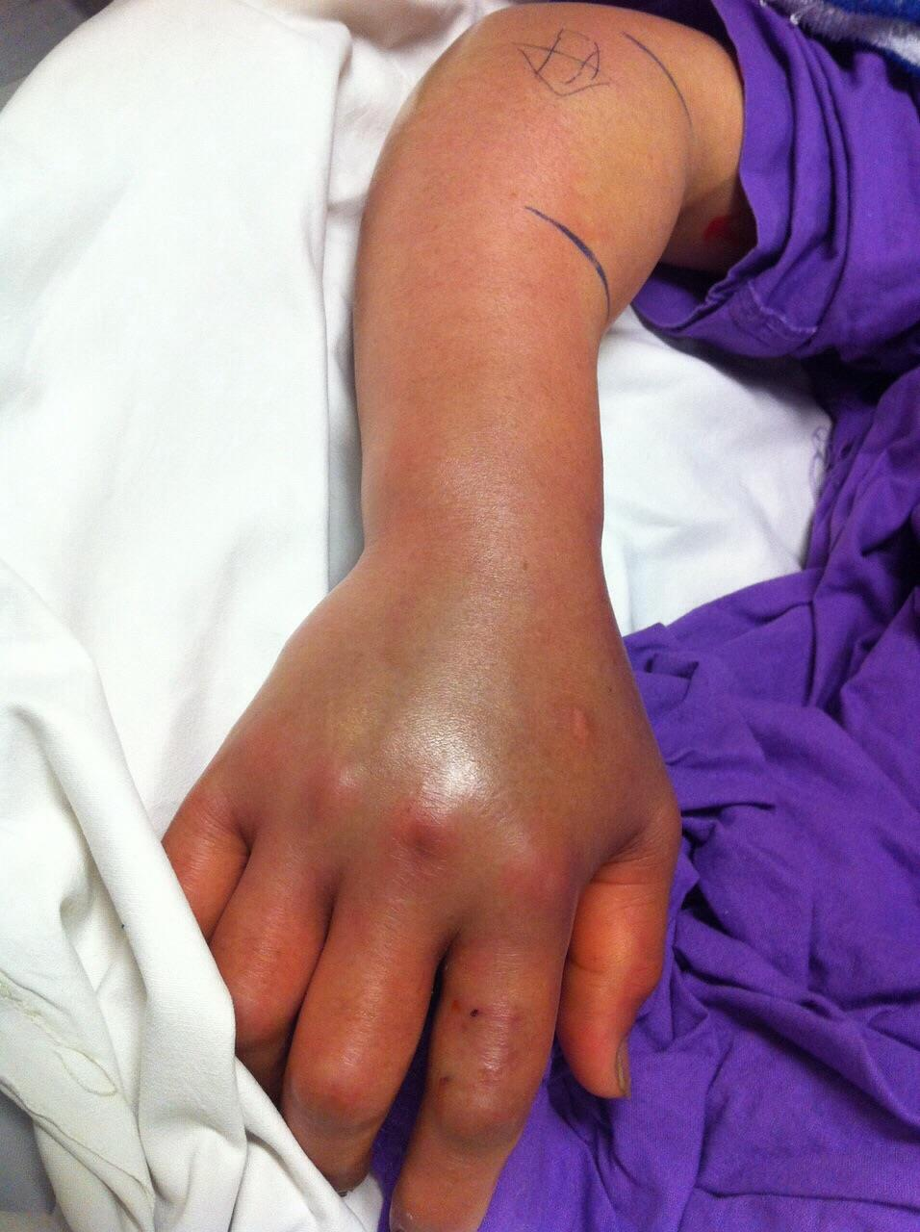

4.1 Name 2 clinical features which may suggest significant envenomation by Bamboo snake in this patient? (2 marks)

4.2 Name 4 investigations, with reasons, that would be useful in monitoring of this

patient? (4 marks)

4.3 What 2 anti-venoms are available in HK for this Bamboo snake envenomation? (2 marks)

This patient complained of severe right hand pain despite analgesics. The Orthopedicssurgeon is worrying about compartment syndrome and is planning for fasciotomy.

4.4 What precaution need to be taken BEFORE the surgical procedure? (1 mark)

4.5 What is the percentage of patients requiring operation after Bamboo snake bites? (1 mark)

Q5. A 39-year-old man with unremarkable past health attended AED for seizure.

5.1 Name 4 causes of seizure. (4 marks)

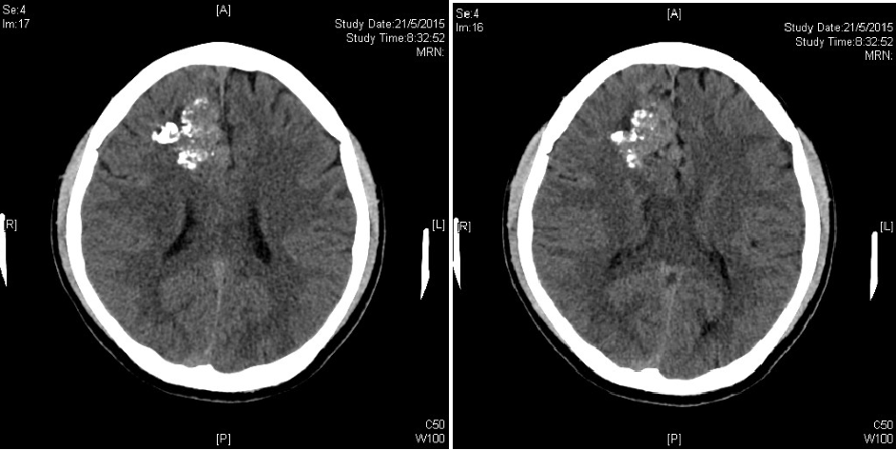

5.2 Describe 2 CT abnormalities? (2 marks)

5.3 What is the likely diagnosis? (1 mark)

5.4 What is the most important and useful investigation of choice? (1 mark)

5.5 Name 2 definite treatment options? (2 marks)